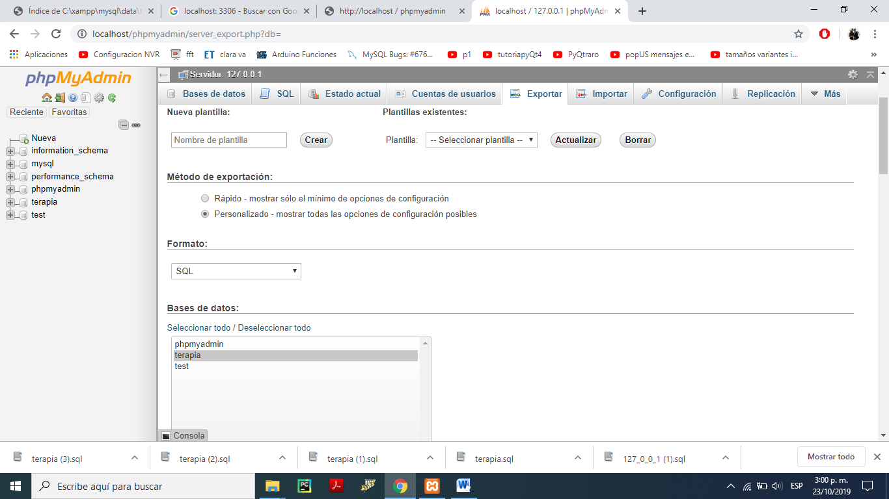

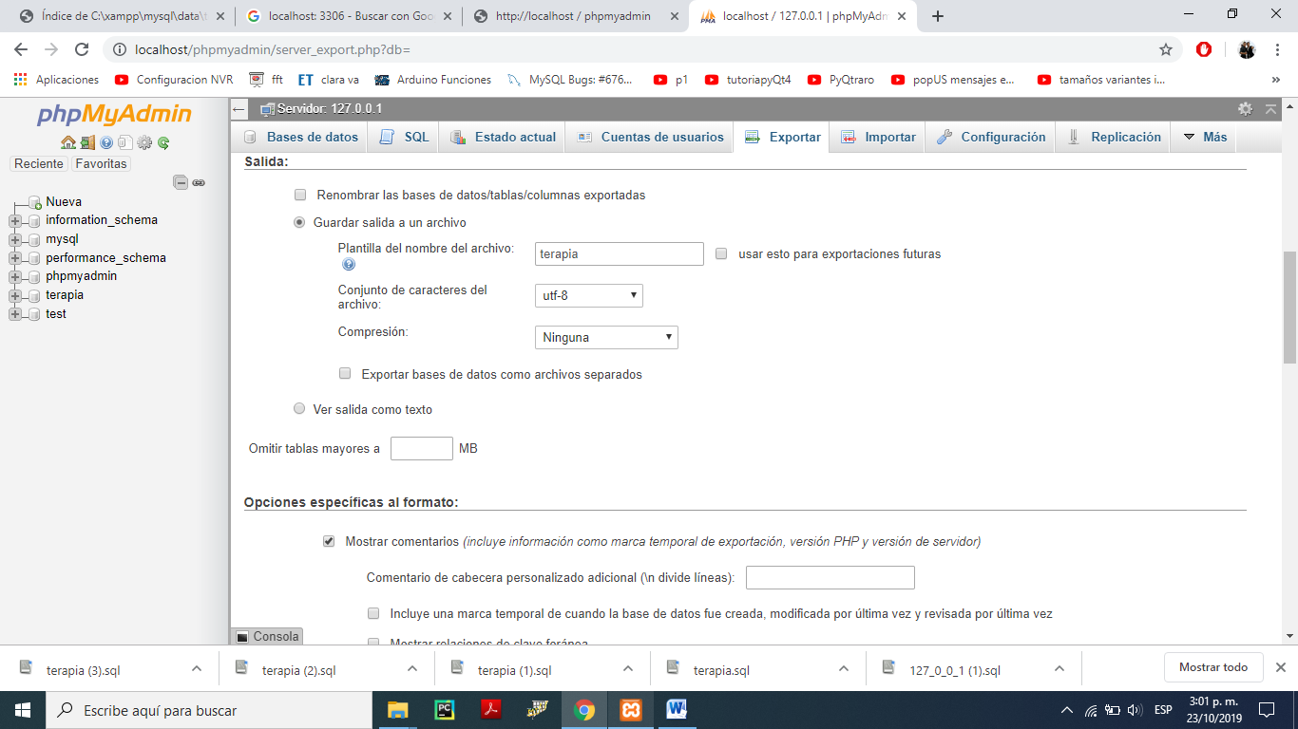

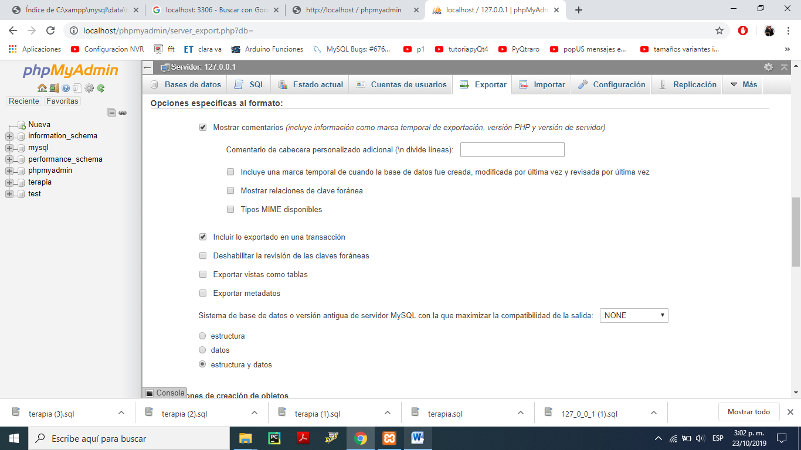

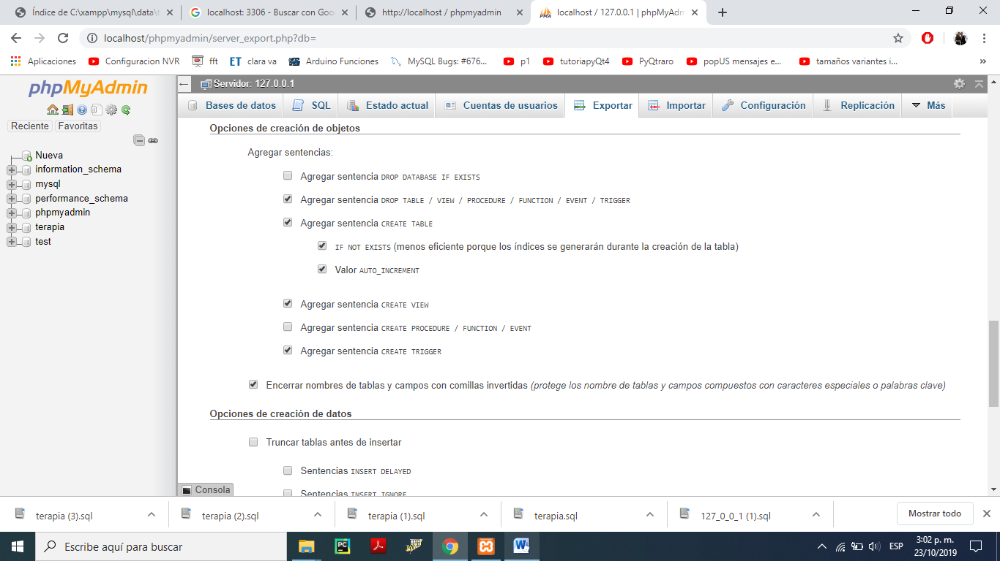

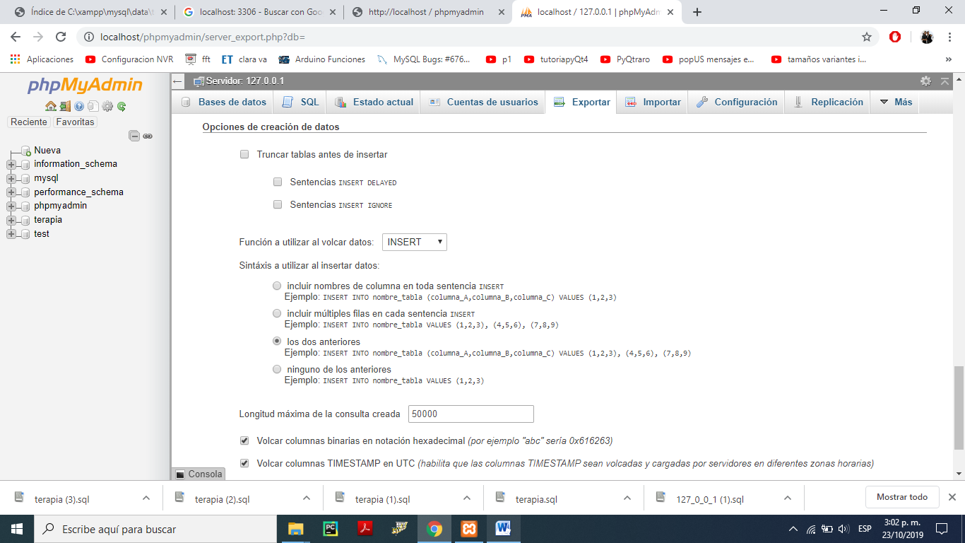

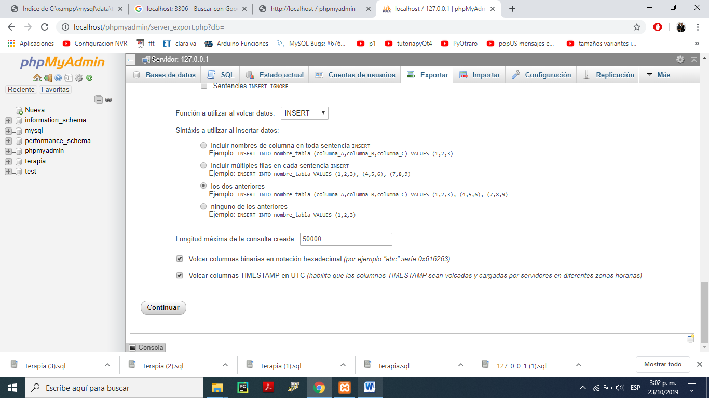

Mas info:

<https://mediatemple.net/community/products/dv/204403864/export-and-import-mysql-databases>

<https://serverfault.com/questions/104470/how-to-copy-move-mysql-database>

<https://www.youtube.com/watch?v=MP3zs0krJ3Q>

Errorrrrrrrrrrrr de los .exe

<https://stackoverflow.com/questions/33743493/why-visual-studio-2015-cant-run-exe-file-ucrtbased-dll>

Verificar que el depurador este x64 en visual studio( importante visual studio 2017)

<https://docs.microsoft.com/en-us/cpp/build/open-folder-projects-cpp?view=vs-2019>

**PARA PYTHON 2.7**

Usar anaconda para la descarga del Python.

**PARA PYTHON 3**

Instalar pyqt5, pyqtgraph, pyOpengGL, pyrr, auto-py-to-exe, matplotlib,pyglut,Wheel,glewpy (TODO POR PYCHARM)

Instalar pyOpengl usando el archivo .whl ( se puede descargar de la pagina <https://www.lfd.uci.edu/~gohlke/pythonlibs/#pyopengl>)

